Introduction to Deep Learning
Deep learning is an aspect of artificial intelligence (AI) that is to simulate the activity of the human brain specifically, pattern recognition by passing input through various layers of the neural network.
A deep neural network is a neural network with atleast two layers. Deep neural networks use sophisticated mathematical modeling to process data in different ways. Traditional machine learning algorithms are linear, deep learning algorithms are stacked in a hierarchy.
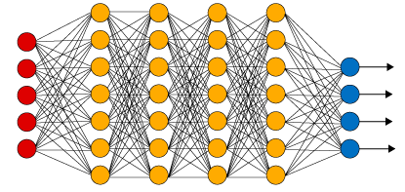
Fig. Deep Neural Network

Deep Learning Applications: There are various interesting applications for Deep Learning that made impossible things before a decade into reality. Some of them are:
- Color restoration,where a given image in greyscale is automatically turned into a colored one.
- Recognizing hand written message.
- Adding sound to a silent video that matches with the scene taking place.
- Self-driving cars

Historical background

All the algorithms that are used in deep learning are largely inspired by the way neurons and neural networks function and process data in the brain. This image is one of the very first pictures of a neuron. It was drawn by Santiago Ramon y Cajal, back in 1899 based on what he saw after placing a pigeon's brain under the microscope. He is now known as the father of modern neuroscience.
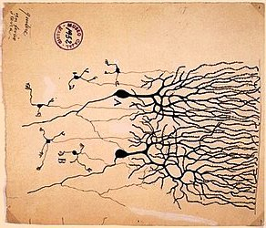
Fig. Human Neural Functioning

It is possible to mimic certain parts of neurons, such as dendrites, cell bodies and axons using simplified mathematical models of what limited knowledge we have on their inner workings: signals can be received from dendrites, and sent down the axon once enough signals were received. This outgoing signal can then be used as another input for other neurons, repeating the process. Some signals are more important than others and can trigger some neurons to fire easier. Connections can become stronger or weaker, new connections can appear while others can cease to exist.

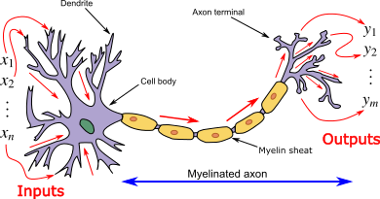
Fig. Biological Neuron

An artificial neuron behaves in the same way as a biological neuron. So it consists of a soma, dendrites, and an axon to pass on the output of this neuron to other neurons. The end of the axon can branch off to connect to many other neurons, but for simplicity we are just showing one branch here. We can mimic most of this process by coming up with a function that receives a list of weighted input signals and outputs some kind of signal if the sum of these weighted inputs reach a certain bias.

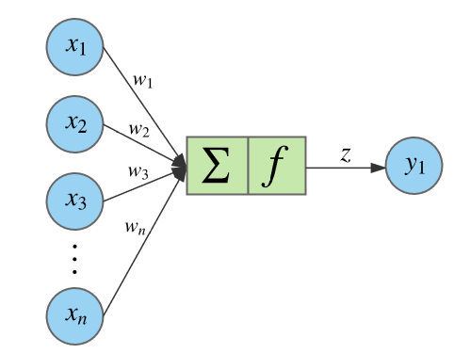
Fig. Artificial Neuron

References:
- https://searchenterpriseai.techtarget.com/definition/deep-learning-deep-neural-network
- https://skymind.ai/wiki/neural-network#concrete
- https://www.cs.uaf.edu/2007/fall/cs441/proj1notes/schamel/
- https://en.wikipedia.org/wiki/Biological_neuron_model
- https://www.edx.org/course/deep-learning-fundamentals-with-keras
- https://medium.com/datathings/neural-networks-and-backpropagation-explained-in-a-simple-way-f540a3611f5e

